|  |  |
| --- | --- |
| RAS  Advanced Quick Start Guide | Abstract  This document provides users with a quick way to get started using RAS. |

# Table of Contents

Introduction 2

Getting Started 3

Data Visualization Workflow 5

Creating Filters 6

1. Select the assets whose data will be included 6

2. Select the properties to be included 7

3. Select data range 8

4. Select time range 9

5. Complete our filter 10

Creating Dashboards 11

# Introduction

This document is meant as a quick start guide for RAS users who plan on using the more advanced functionality in RAS. Before reading this document, we recommend reading the Basic Quick Start Guide, which outlines how to use the web application in general, as well as the RAS Lexicon, which explains some commonly used terms. By the end of this guide, you’ll be able to create your own custom dashboards, using real-life data.

# Getting Started

Use your browser to navigate to <http://ras.leclanche.com> and log in using the credentials provided to you.

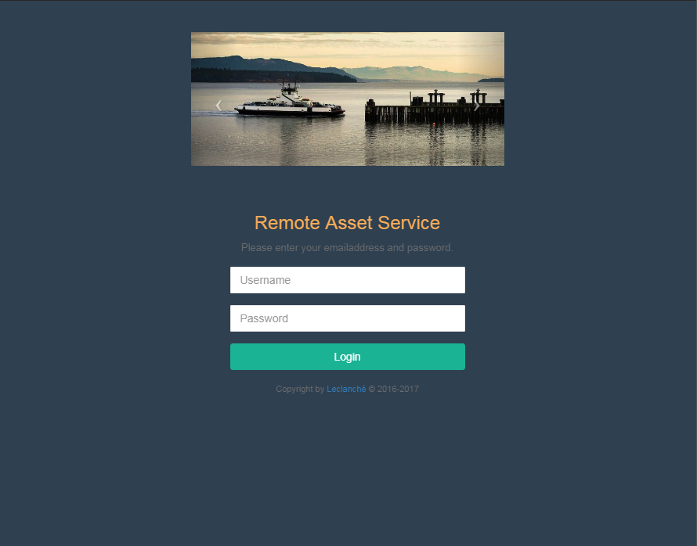

Once logged in, you’ll be greeted with the following screen

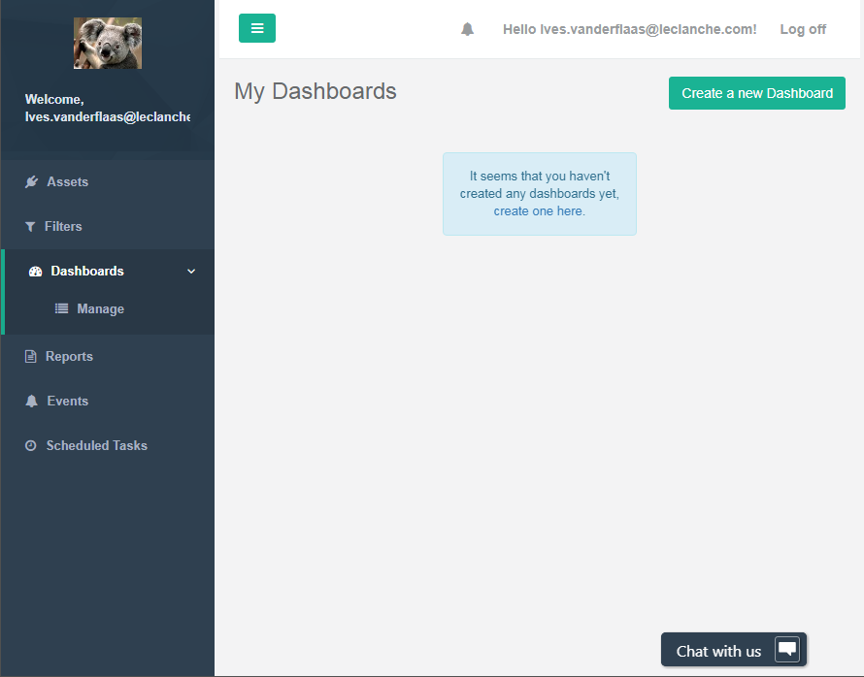

The page can be divided into three sections with distinct functions. On the left you’ll find the menu bar, which is used to navigate the different RAS modules. The remainder of the screen is split into the top section, which allows users to log out and view their notifications through the bell icon, and the bottom section which displays the contents of the currently selected module.

In the “Assets” module, available in the menu bar, you’ll see which assets are available to your company. You can click each of these assets to view some details about the assets.

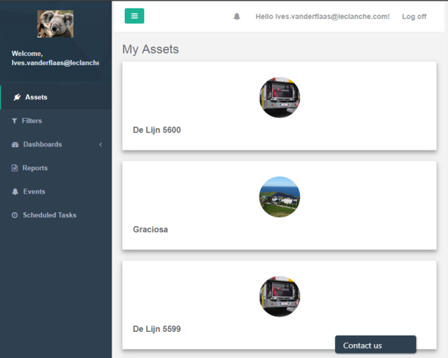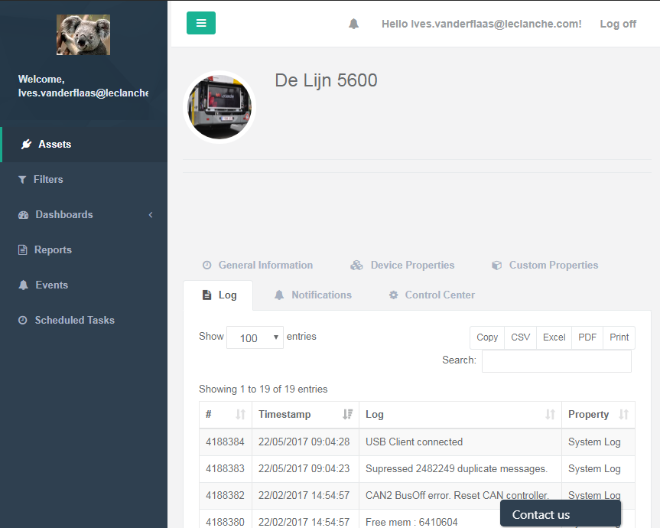

# Data Visualization Workflow

In RAS, data is visualized using what we call Dashboards. A dashboard can contain graphs, maps, tables and more. Before you can create a dashboard, you first need to define a filter. Filters specify a data set that can be used by a dashboard. When creating your dashboard, you must specify the filter you want to use.

# Creating Filters

Creating a filter is an essential part of data visualization in RAS. You can create a new filter by clicking the “Create a new filter” button after clicking the “Filters” module in the menu.

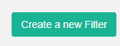

Creating a filter is a five-step process. This chapter will guide you through the creation of a filter that will be used to create a dashboard in the next chapter.

## Select the assets whose data will be included

On this page, the assets whose data will be included in the filter (and the eventual dashboard) can be selected by clicking them. You should select as few assets as possible to achieve the best performance.

In our example, the assets we’ll select are “De Lijn 5599” and “De Lijn 5600”.

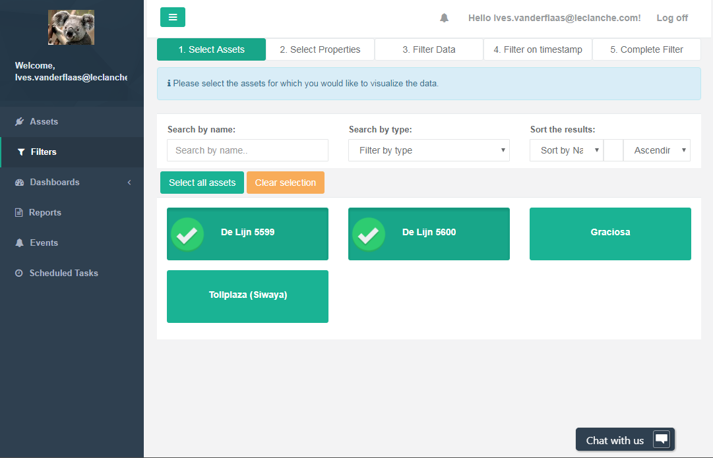

## Select the properties to be included

In the second step, a list of all properties available for the selected assets is shown. By selecting properties, they will be made available for use in a Dashboard. Users should select as few properties as possible to ensure optimal performance.

In our running example, only the BATCURRENT property is chosen. When creating our dashboard, we’ll graph the battery current (BATCURRENT) for both the buses we selected.

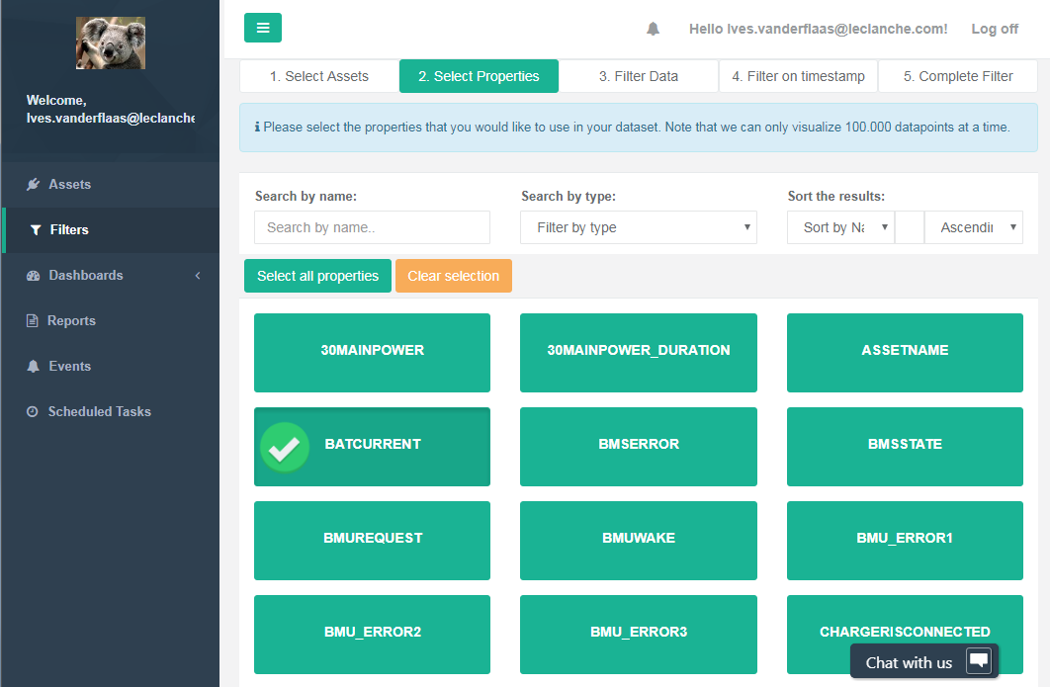

## 3. Select data range

In the “Filter Data” tab, a list of selected properties and their ranges is shown. By checking the relevant “Enable Filter” checkbox, parts of the range for that property can be selected.

In our running example, we won’t check the “Enable Filter” checkbox.

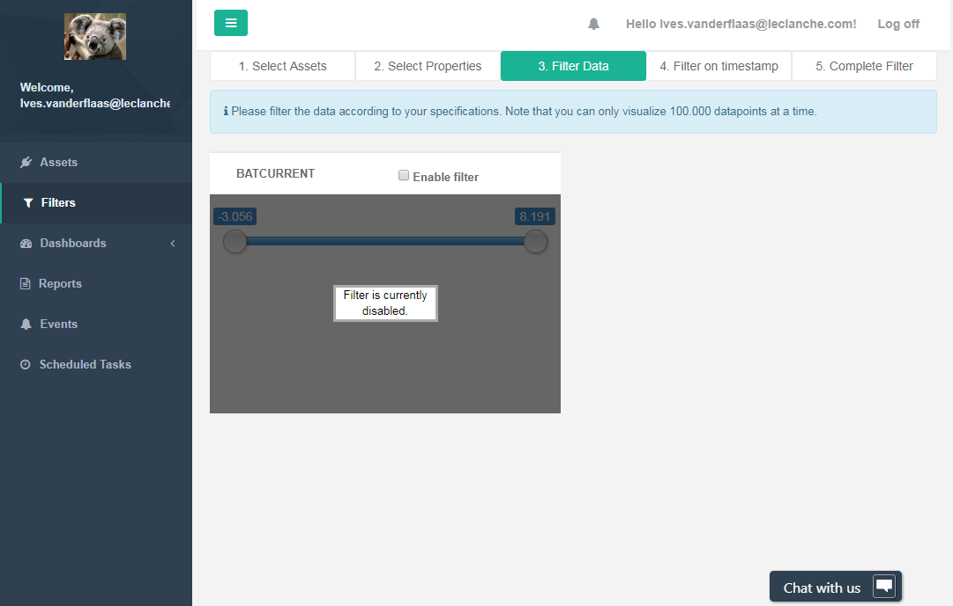

## 4. Select time range

It’s possible to restrict the time range in which data will be returned. The time range can be restricted to a relative period (e.g. last week) or an absolute period (e.g. from the first of January 2016 to the fifth of May 2016).

We won’t filter our time range in our running example.

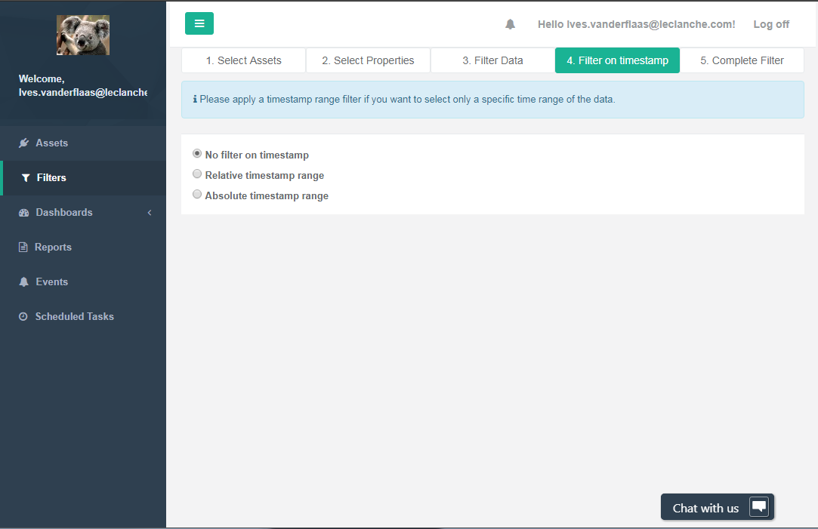

## 5. Complete our filter

In the fifth and final step of the filter creation wizard, we get a preview of the data the filter will output, as well as give our filter a name.

We’ll name the example filter “BATCURRENT for buses”.

# 

# Creating Dashboards

In this section we’ll walk you through the creation of a simple dashboard, visualizing the property you selected earlier when creating your filter.

Navigate to the Dashboards model and click the “Create New Dashboard” button near the top right of the screen.

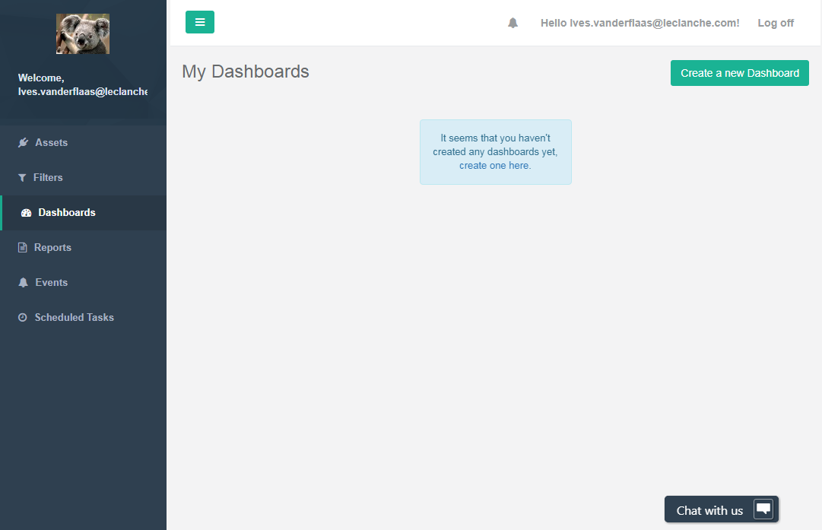

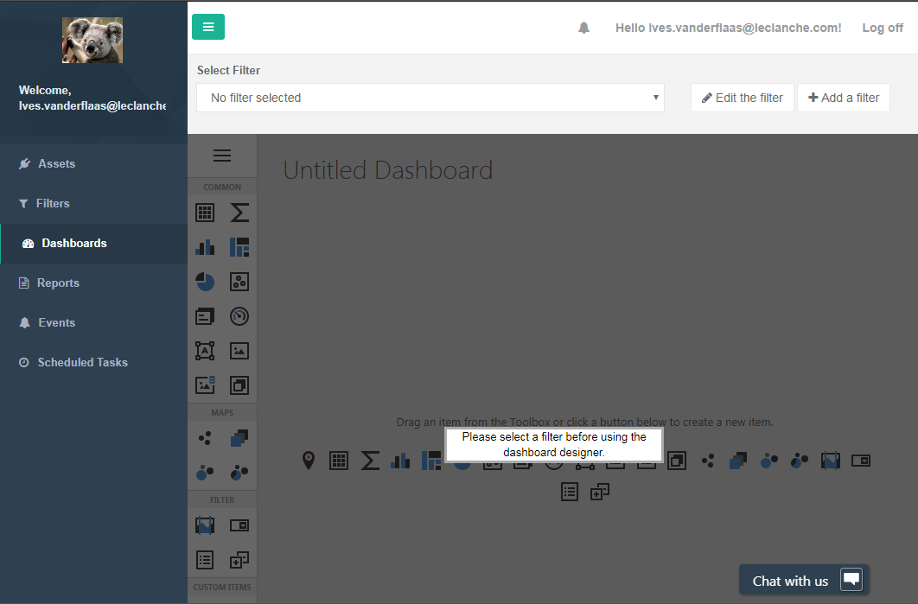

Select the filter that was created earlier in the dropdown near the top of the page.

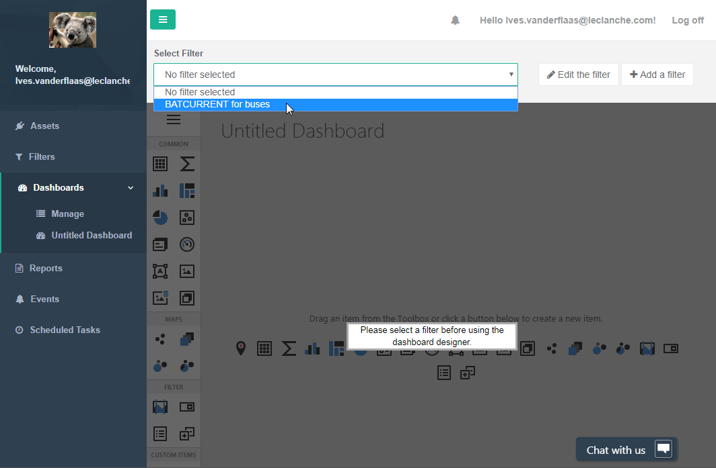

Once a filter is selected, you’ll be able to use the dashboard designer. Once the designer is enabled, click the “hamburger” icon near the top of the designer.

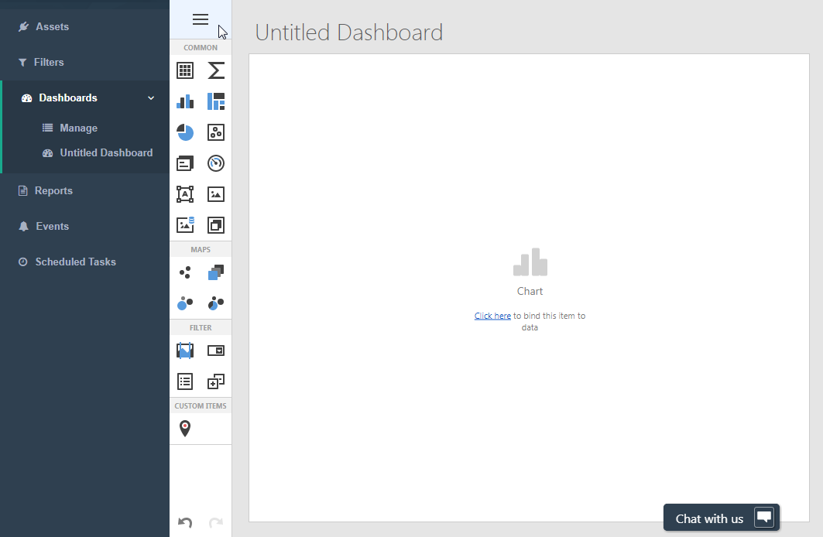

Then click data sources.

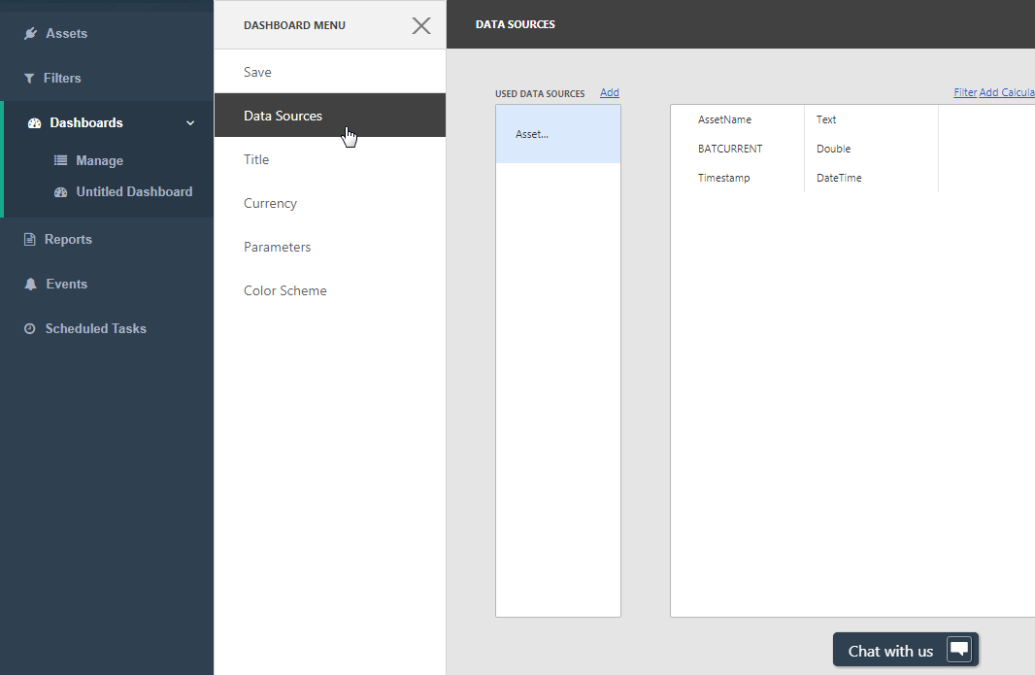

On the right, the three available properties “AssetName”, “BATCURRENT” and “Timestamp” can be seen. AssetName and Timestamp are always present in this list, as they are associated with every data point.

Close the Data Sources screen by clicking the X to the right of “DASHBOARD MENU”. Then click the “Chart” icon.

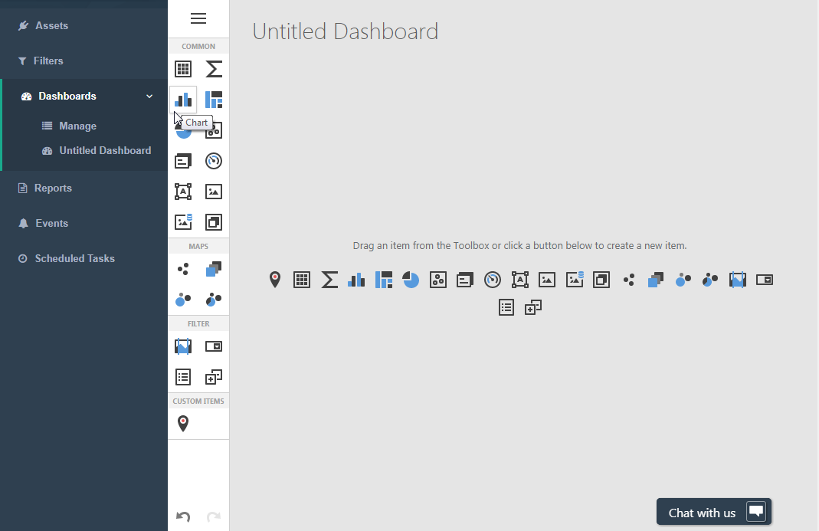

Then click the “Bindings” cogwheel:

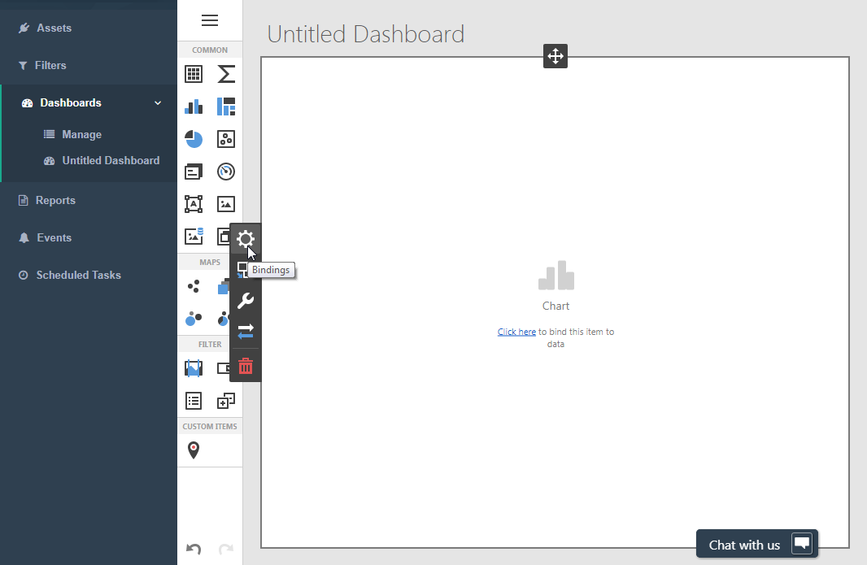

When the bindings dialog appears, click the “Add Values” button and the BATCURRENT property. Make sure to select the “Line” type of graph under “Type”.

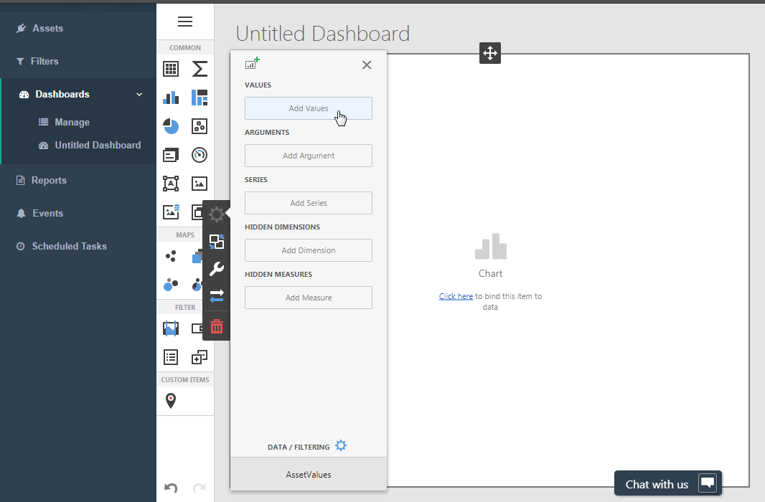

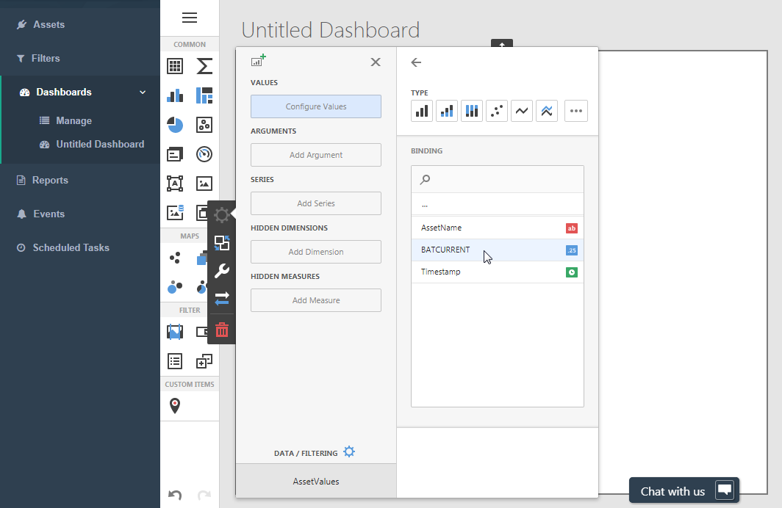

Then select “Average” instead of “Sum” under Summary Type. If multiple BATCURRENT values were to exist for some point in time, the system would average them out rather than add them up.

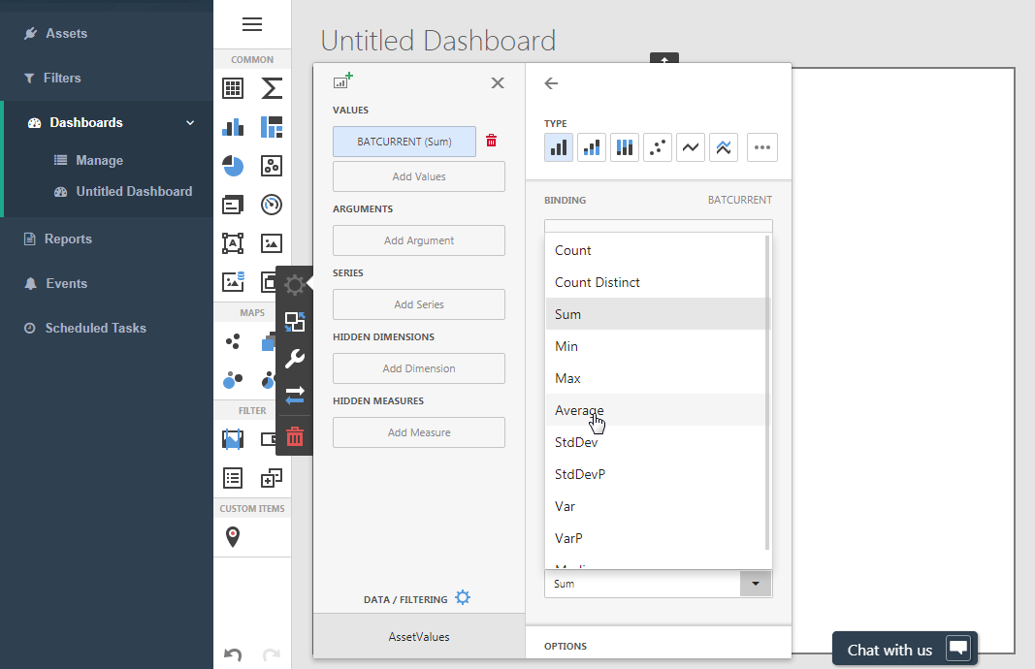

Under arguments, select Timestamp and set the grouping interval to date-hour-minute-second. The grouping interval you select in this step determines what values are averaged. In our example, we’d like all data to be visualized so we decide to group by the smallest possible interval (second).

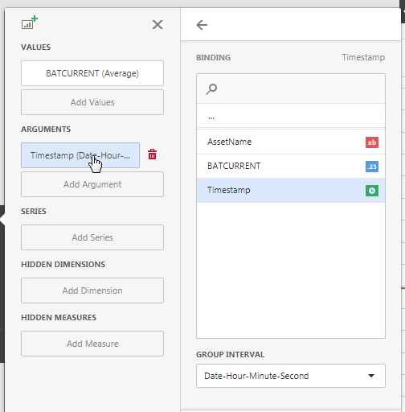

Under series, set the binding to AssetName. Doing so will separate the BATCURRENT data into two “streams” of data: one for each distinct AssetName. If we were to include the BATCURRENT data for five buses in our filter, five series of data would appear in the graph.

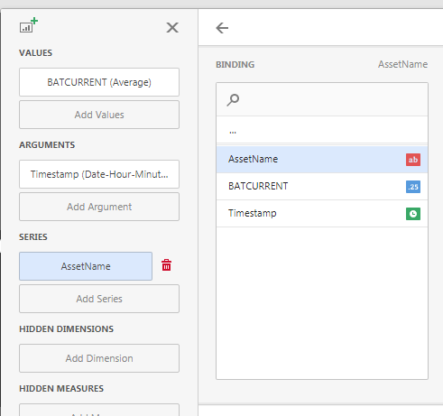

Close the configuration pane and after a few seconds the data will load and you’ll see your very first dashboard!

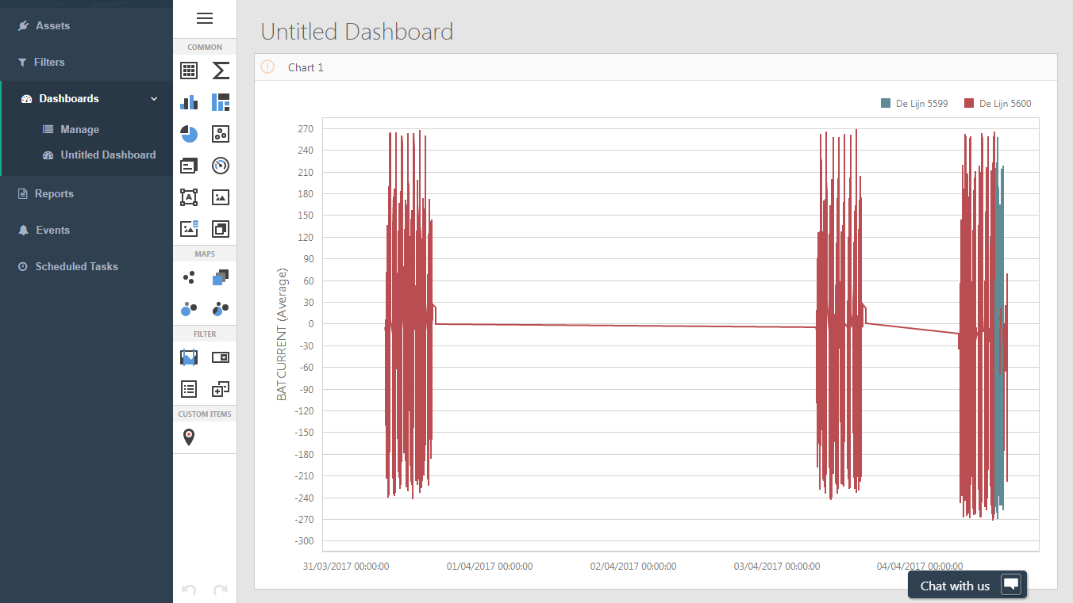

The next logical step is to give a name to the new dashboard. Click the hamburger icon on the top left and click title. Enter an appropriate title under “Text”.

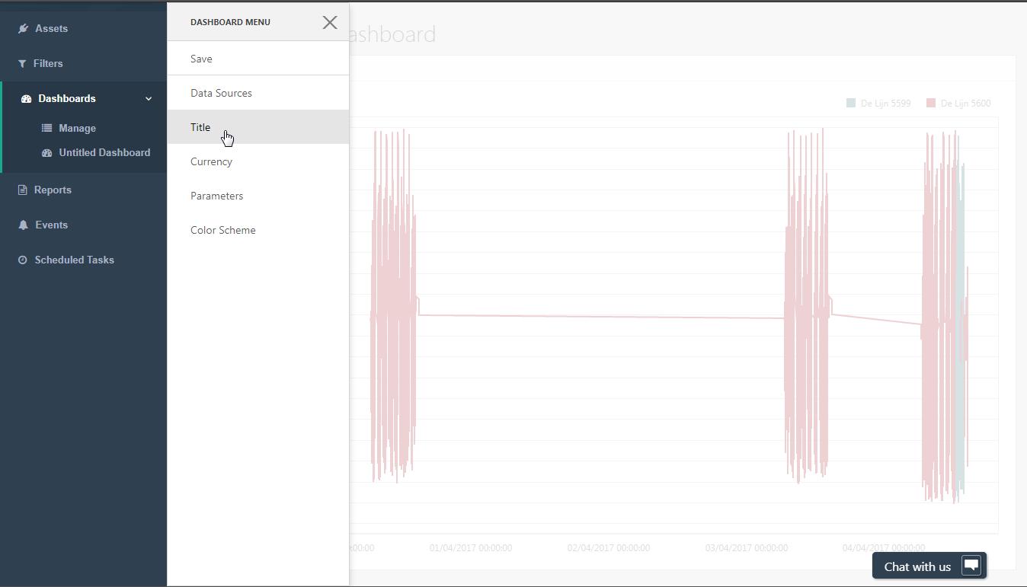

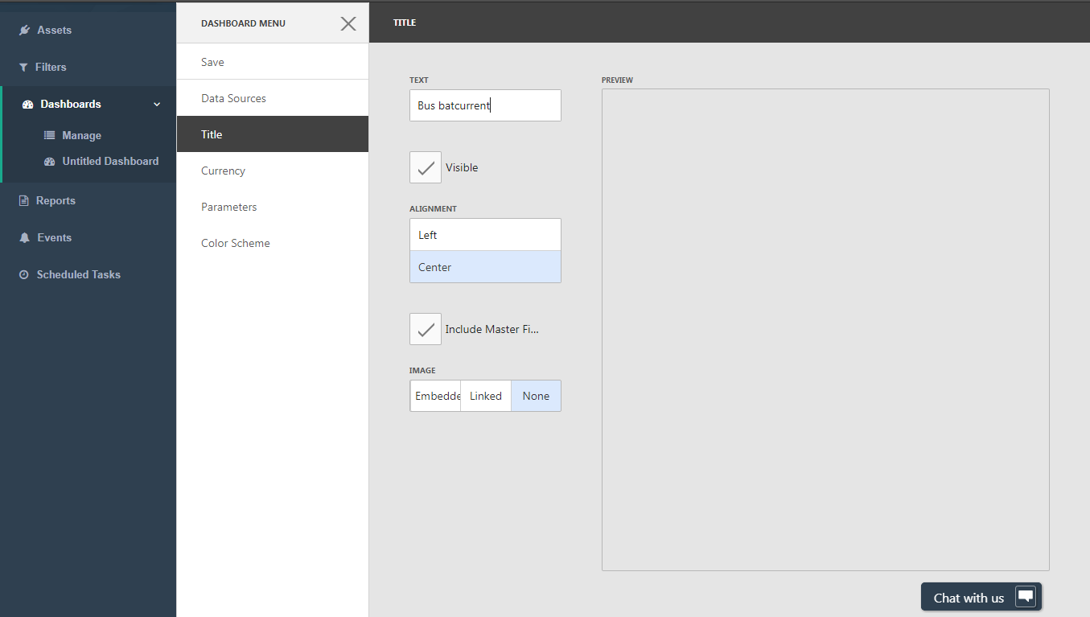

Now save your work by clicking the “Save” button:

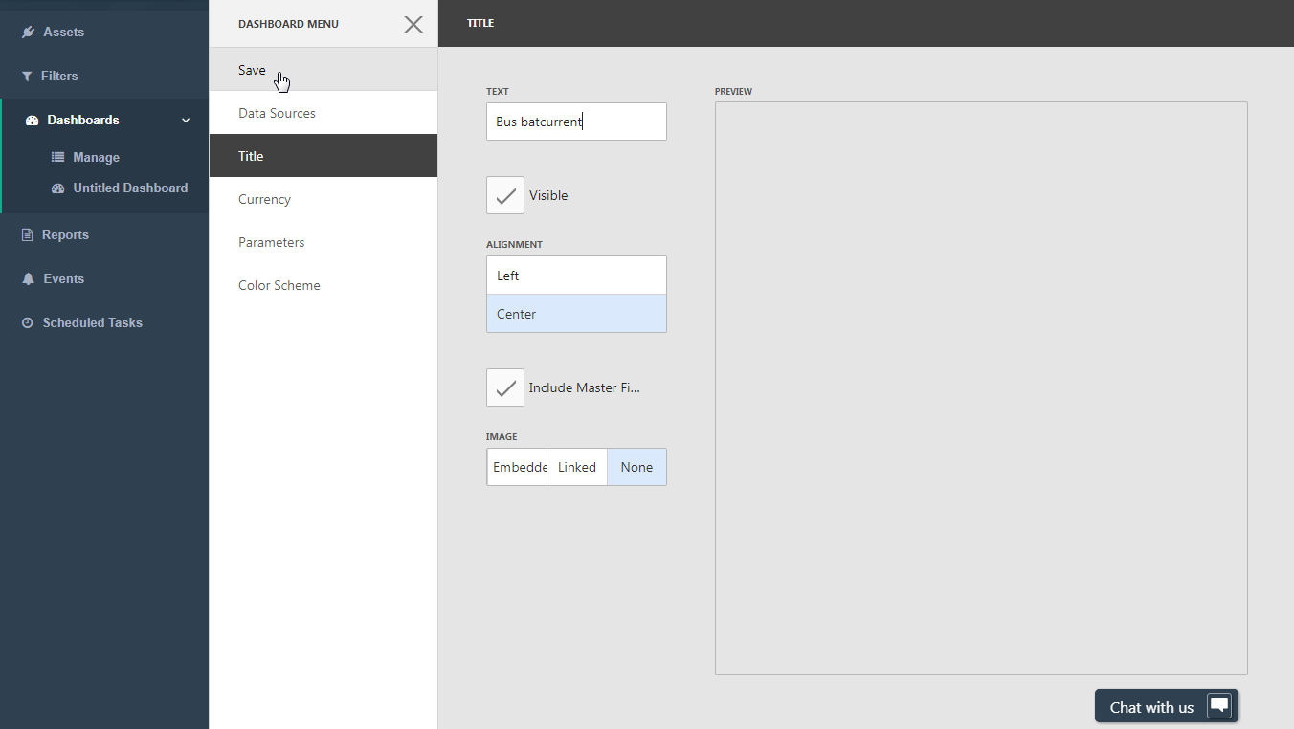

After saving, your dashboard will appear among the list of dashboards that appears when logging onto RAS.

